

College of Science and Technology

School of Science and Technology

# **ITEC31041: Mobile Platform Applications**

# **Mobile Application Proposal**

*By*

*N0719715: Suraj Mistry*

NTU Karate Management Application

Contents

**ITEC31041: Mobile Platform Applications** 0

**Mobile Application Proposal** 0

Executive Summary 2

Proposed Solution 2

Software and Hardware Development Options 3

Reasons for Android 4

Usability and Guidelines 4

Requirements and Constraints 5

Functional Requirements 5

Constraints 6

Proposed Idea and Impact 6

App Features 7

Evaluation of Paper Prototype 7

References 9

Appendix 9

Personas 9

Paper Prototype: 0

## Executive Summary

This project will address the issues with managing the Nottingham Trent University (NTU) Karate Sports Society. The Karate society is directly managed by a five-person committee, who each cover the following roles of the club:

* President
* Treasurer
* Secretary
* Social (Male & Female)

The President will oversee the rest of the committee, while also managing the club in general making the final key decisions. This however can be very difficult for the President to manage, as there is no there is specific process to follow, consequently most tasks must be actioned manually. The club has over 40 members, each of which can pursue one of three different memberships schemes. Members will range from beginners with no Karate background to those with years of experience in the martial art. The experienced members will also differ in grade, Karate style and organisation. As there is such variety among the members of the Karate Club, is it very difficult for the President to record this information in a centralised location where the data is securely stored and easily editable. In addition to this, as the club is currently affiliated with the Karate Union of Great Britain (KUGB), all members must possess a KUGB licence and so all licence numbers and expiration dates must be also recorded. As the committee do not have access to the NTU sport system, which records all general membership information, the President must manually record this data in a spreadsheet along with the Karate-related details. For the several Karate competitions that occur throughout the academic year, all entries will be recorded into a spreadsheet in order to track how many members are competing, the overall cost and the events entered. In a separate spreadsheet, the President records each member’s performance in the competitions. A similar process is used for organising the several Karate competitions. The overall issue with this process is that it is extremely time consuming, error-prone and insecure.

Another issue with the NTU Karate society is specifically for the training aspects. As mentioned above, the club is affiliated with the KUGB and thus follows the associated Shotokan Karate syllabus. Beginners or less experienced members who join the club, will become official KUGB members and follow the grading process. The syllabus is available online, via the KUGB web site along with a glossary of terms used during training. However, the syllabus is only written using the Japanese terms and so beginners who do not know the translations, must constantly switch between the syllabus document and glossary in order to find what is required for each grading. This is a very time-consuming and cumbersome process, which can potentially cause confusion for the less experienced members and ultimately hinder their progress with the martial art.

### Proposed Solution

In order to combat these issues a Karate club management and Training tool will be created in the form of an Android mobile application.

The management aspect of the app will allow the President and their committee to easily record and update all relevant details for members. They will be able to track the progress of each member by their grade and competition record. The application will also act as an event management system for Karate competitions and other social events that occur during the year, allowing the committee to effortlessly track the attendees for each competition/event.

For the training side of the tool, it will provide members with the ability to keep up with training outside of the dojo. For beginners, the main syllabus will be visible in a much more readable presentation using both the English and Japanese terms to avoid confusion but still allowing them to learn the Japanese terms which are used during training and in gradings. Furthermore, for the benefit of more experienced members who are often competing, the application will include further training assistance for Karate sparring in a video format.

## Software and Hardware Development Options

Mobile technology is a rapidly growing industry, with manufacturers constantly developing new features for their devices, while also improving the existing features. A mobile application can provide several benefits, which can aid the society for the foreseeable future.

The overall goal of a mobile application is to provide a simple and effective solution, that can be used on portable devices such as, smartphones, smartwatches, tablets etc. Mobile apps usually perform tasks much faster than mobile website, due to the data being store locally on the device and running on faster frameworks. They offer a more seamless experience allowing users quick access content on their devices. Applications can also make use of push notifications, these are instant and non-intrusive notifications sent to the user. For example, they can be used for sending event reminders, instant updates and many other alerts. Mobile applications, unlike websites, can take full advantage of a smart device, utilising the swipe gestures performed on the touchscreen, resulting in a more user-friendly experience.

A great advantage of mobile applications is the ability to utilise the many feature of the device. Once the app is downloaded it can use the following features:

* Camera: This can be used as a scanning tool for QR and Bar codes, as well as taking photographs for identification purposes. Some smartphones also feature a Time of Flight camera, which is used as a depth sensor, allowing for a more 3-dimensional view.
* NFC (Near Field Communication): NFC allows the transfer of data between devices. Currently its most popular usage is for contactless payment, however it can also be used to send images and other files.
* GPS: Locations tracking for maps and other applications.
* Accelerometer/Gyro-meter: Can be used for numerous different purposes, an example of this would be tracking steps for ‘health’ applications.
* Biometric Security: Fingerprint scanners and facial recognition can be used to provide extra security, especially when handling personal and sensitive data.
* Bluetooth: Bluetooth could be used to connect external devices to the mobile device and is also used to transfer data.

Much like desktop computers and laptops run on MacOS, Linux or Windows, mobile devices run on specifically designed operating systems. Presently the most popular mobile operating systems are Android and iOS, with Microsoft also having a mobile version of Windows. Apple’s iOS is a proprietary operating system, only available on devices manufactured by the company, such as the iPhone, iPad, iPod and a special version of the software for the Apple Watch series. iOS is a very simple, secure and intuitive system, which optimises applications as it is found only on Apple products. Android is an open source operating system owned by Google and can be found on devices made by Google, Samsung, OnePlus etc. It is used on over one billion devices around the world and has a highly customisable interface.

### Reasons for Android

This application will be made for the Android operating system. The main advantage of developing for Android is that it is the most used operating system worldwide. Approximately 75% of people around the world use Android, whereas iOS is only used by around 19%, with the remaining percentage being Windows and various other operating systems. This is due to Android not being restricted to just one mobile device manufacturer, unlike iOS. There are thousands of small and large companies that make devices for Android and so ultimately is the more accessible platform. The only issue this could present is that the application will need to run on a large amount of device which differ in form factor. The main benefit of iOS is that the application can be optimised for the small range of Apple devices.

From a development perspective Android apps can be built on almost any computer, whereas a Mac is required to develop iOS apps. Furthermore, the cost of publishing apps on to the Google Play Store, is much cheaper than on Apple’s App Store and it also takes longer for the app to be approved.

## Usability and Guidelines

The target demographic for this application will be university students who are interested or training in Karate. As a result of this, the average user will be aged 18 to 23 and able-bodied, due to the nature of the sport/martial art. One assumption that could be made is that this age range will have a higher technical capability than others, however for the society to really benefit from the application, it must still have a simple design and easy to use. Again, considering the target age range, there wouldn’t be a requirement for a specialised font size or style to compensate. Ultimately, the font must be easily readable to the average person, whilst also considering those with common visual impairments such as colour-blindness

Since the application itself is being created for the Nottingham Trent University (NTU) Karate Society, naturally the appropriate colour scheme to use would match those of NTU Sport. The application interface will follow the NTU style guides (example below) to ensure a consistent design across other NTU software. In addition to the NTU style, it will also follow Google’s material design guidelines. This will provide the application with a modern look, be stylistically consistent and easy to use. The Google design guideline will allow the NTU and NTU Karate branding to be incorporated seamlessly into the application’s user interface.

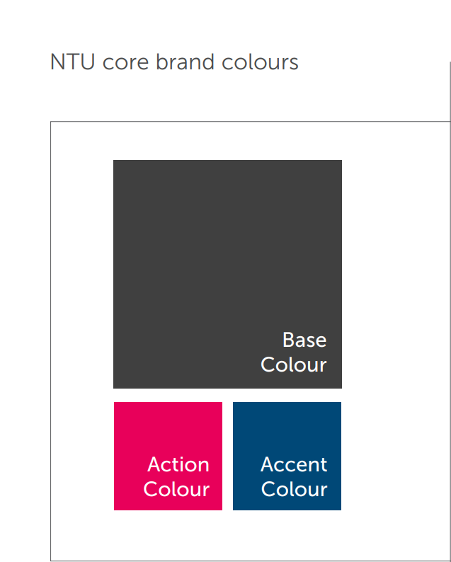

1: NTU, 2019. Project Reboot Digital Style Guide.

## Requirements and Constraints

### Functional Requirements

The following requirements will be for all users of the application. The users must be able to:

* Create a new user account
* Log into the application
* Change their user name and passwords
* View all information regarding karate and social events and register their attendance
* View and update their personal information:
* View and update their competitive record
* See all official grading information
* Access glossary of Japanese terms used in the Dojo and how to pronounce them
* Watch video tutorials for all Katas and other training techniques

Only Admin users must be able to:

* View and update details for all users
* Create new social and Karate events
* Add new training tips and guides with videos if necessary
* Remove user accounts
* Make other user accounts admin accounts

### Constraints

* The application will always require access to the internet to maintain connection to database and allow users to see location of events on a map.
* The database will require maintenance support, to ensure no bad data is processed through the system.
* Presidents will need to ‘handover’ admin after each academic year if there is a changeover in roles.
* Users account for those finishing university and leaving the society will require removing
* Due to GPS being used for the map area the system may function better outside, rather than indoors.

## Proposed Idea and Impact

The goal of this application is to minimise the time spent by the NTU Karate club’s President and committee organising and managing details regarding each member and can easily track competitive record. It will also provide a plethora of significant information about the formal training process according to the official KUGB syllabus and give helpful training tips for sport Karate using video guides.

The management side of the app will only be accessible to the President of the Karate sports society and the committee. They will have the ability to view a profile of each member and easily keep their details up to date. Events will be created by these Admins users which will then appear on the events page, allowing members to view information regarding the events and register their attendance. The club management aspect of the application will have the greatest impact for the society, as it will decrease the amount of time spent organising and updating the current spreadsheets, significantly reduce the risk of the errors occurring and hugely boost the efficiency of managing the club.

For novice members of the society, the training feature will be remarkably beneficial to the official training process. The application will provide them with an easy to use location which they can access all the training material outside the dojo, required to progress through the syllabus. This could result in enticing more members to going through the grading system and ultimately improve their karate ability.

For member who have a vast background in the martial arts and want to improve their Kumite (sparring) and Kata (Long choreographed combinations) skills outside of the dojo, the training section will also include many training tips and techniques. As their ability progresses, it will result in better performances in competitions and boost the success of the society.

## App Features

The following section will highlight the several technical features the application will encompass in order to achieve the desired product.

|  |  |  |
| --- | --- | --- |
| Feature | Persona(s) | Outcome |
| Login Page | President and Committee (Admin)  Members | Ensure each member and committee member has their own personal account for the application. Will allow them to log in or create a new account. |
| Link to database | President and Committee (Admin)  Members | Location for all user detail, events and training information will be securely stored. The users will access this data via the application. |
| Video Tutorials | President and Committee (Admin)  Members | The training section of the application will include several videos depicting several Karate training tips and Katas |
| Simple map function | President and Committee (Admin)  Members | The location of all event will be shown with access to see on map |

## Evaluation of Paper Prototype

See Appendix for Paper Prototype

#### Test Users

Name: Aidan Newberry (Karate President)

Feedback:

* Clean and simple design
* Integrates NTU colours well
* Easy to use meaning current admin tasks would take considerably less time

Improvements:

* Should be able to add new training techniques in Kumite section as new techniques are always being created in the sport
* Have a bottom navigation bar instead of side navigation drawer, since there are very few menu options the bottom bar integrates in a cleaner way

Name: Amaara Ravat (Experienced Karate Member)

Feedback:

* Very nice slick design, not too clustered yet has lots of necessary functionality
* NTU colours only so colour scheme is very simple and clean
* Includes helpful functionality for members, very informative and easy to follow

Improvements:

* Navigation side draw not necessary as there are only a maximum of five menu options, which can display nicely at the bottom instead
* Give standard users the ability to update their own medal tally as this will mean the admins will spend less time recording the information themselves.

System will be built using and bottom navigation bar allow to navigate to different parts of the application as this was preferred by the test users for a cleaner solution. These will be:

* Events
* User Profile
* Members (Admin Only)
* Training
* Settings

The main content consisting of the list view, text views etc, of each segment will be display within its own fragment, meaning the overall layout of the application will not change, apart from the bottom highlight icon.

#### Events:

Standard users will be able to view all the new events created by the admin and register their attendance. Users will be able all key information regarding the event as well a map fragment for the location. Admin users will be able to create these events and see which members have registered.

#### User Profile:

Users will use this section to view and edit their personal detail, however only admins will be able to edit license number and grade. They can also view and update their competitive record.

#### Members:

Admin only section allows all members’ profiles and competitive record to be viewed and edited.

#### Training:

Training section is split into four section Kata, Kumite, Grading syllabus and Japanese terminology. Each section will aid the user in their training even outside the dojo.

#### Setting:

Inside settings, user will be able to do general account management such as, changing username and password, logout and Delete their account. They can also access useful links available to them, which admin users can add to.

## References

[https://rubygarage.org/blog/ios-vs-android-development 1](https://rubygarage.org/blog/ios-vs-android-development%201)

**Google, 2019. Material Design. Google: Google. Available at:** <https://material.io/design/>

**NTU, 2019. Project Reboot Digital Style Guide. Google: NTU. Available at:** <https://www.ntu.ac.uk/__data/assets/pdf_file/0025/219940/002-Colour-V03.pdf>

**NTU, 2019. Project Reboot Digital Style Guide. Google: NTU. Available at:** <https://www.ntu.ac.uk/c/digital-marketing/how-to-and-guides/the-ntu-brand>

## Appendix

### Personas

|  |  |
| --- | --- |
| Name: Aidan  Age 24 | Demographic:   * President of Nottingham Trent University Karate * 3rd Dan Black belt in Shotokan Karate * Regular competitor in several Karate tournaments * Prefers Kumite (Sparring) * Manages all members of Karate club and organise Karate events |
| Issues with current process:   * Time consuming for organising member details and competitive record * Error prone * Too many locations to access training information for beginners * Difficult to track attendees for events throughout the academic year * Time consuming to record member’s and personal competitive record | Solutions:   * Allow him to access all users details in one location and easily update information * This will result in less errors in the date and will be easier to manage * Provide one location where beginners can access all relevant training information * Ability to create events for these Karate competitions and other social events to allow for easy tracking and managing * Ability to allow members to update their personal competitive record and allow Aidan to see his and all members record |

|  |  |
| --- | --- |
| Name: Holly  Age 19 | Demographic:   * New member of Nottingham Trent University Karate * 10th Kyu White belt in Shotokan Karate (Complete Beginner) * Wants to develop Karate skills and go through the official grading process * Never competed, but would consider competing after more experienced is gained |
| Issues with current process:   * Access to official syllabus is available, however is difficult to follow as all technical terms are in Japanese * Japanese terminology is also available however, again is difficult to follow * Too many locations to find competition information to learn more about the rules and format | Solutions:   * Provide one centralised location with all formal training techniques as well as competition rules which is simple to follow * A more user-friendly glossary of Japanese terms to help Holly learn them during the year * Provide video guides for Katas and training tips for training outside of the dojo |

### Paper Prototype:

#### Standard User

#### 

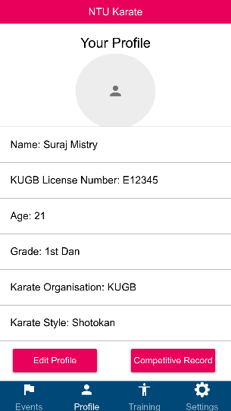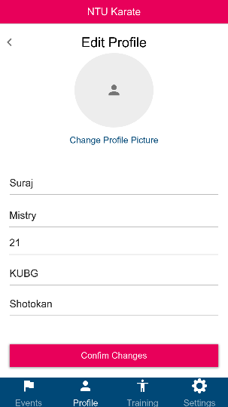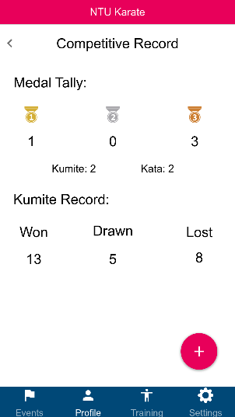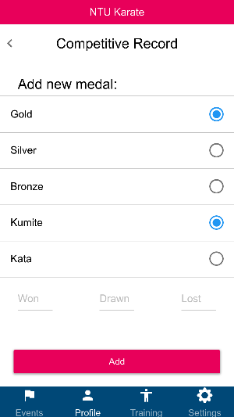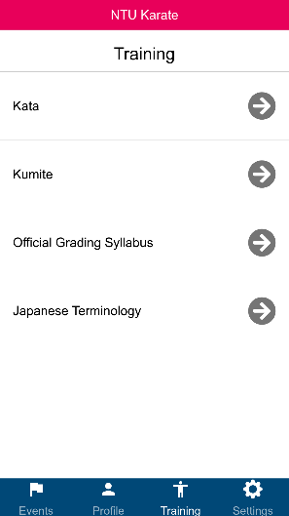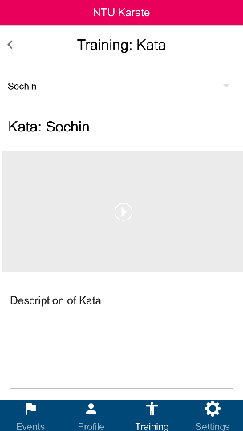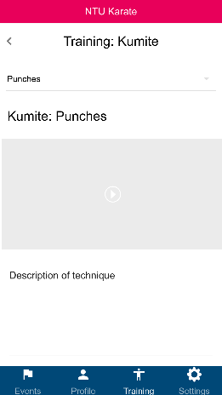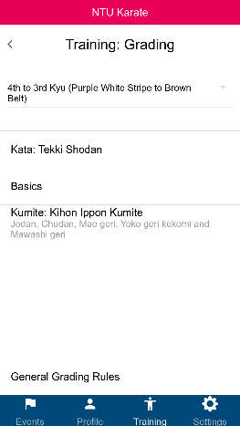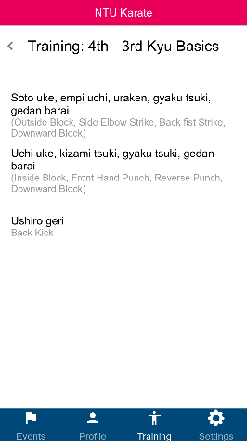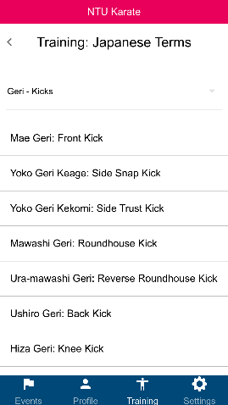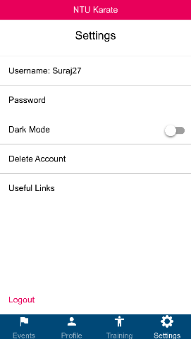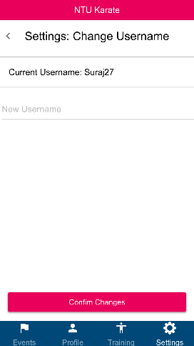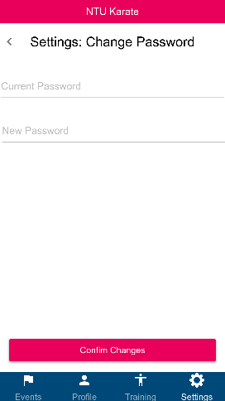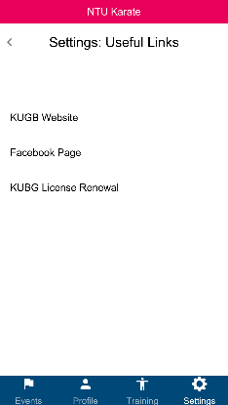

#### Admin User

